**Project Name**. *Tender Corporation*

**Assessment.** *Multilayer SSD + Updated DCD’s*

|  |
| --- |
| Use Cases |
| * ADD COMPANY * ADD ADMINISTRATOR * ADD CLIENT * ADVERTISE TENDER * VIEW TENDER * MAKE TENDER APPLICATION * VIEW APPLICATION * MAKE PAYMENT * APPROVE TENDER * ASSIGN TENDER * UPDATE TENDER * CANCEL TENDER APPLICATION |

**A::MULTILAYER SSD**

1. **[Add Company]**

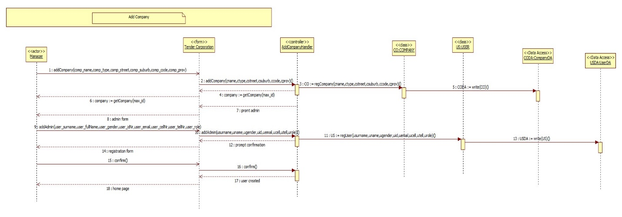

1. **[Advertise Tender]**

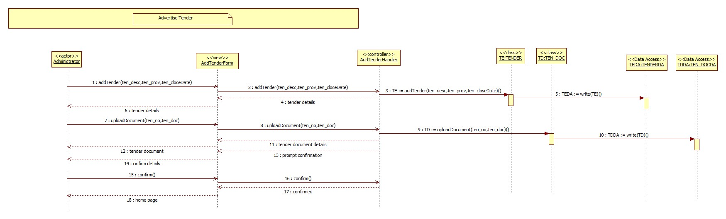

1. **[View Tender Application]**

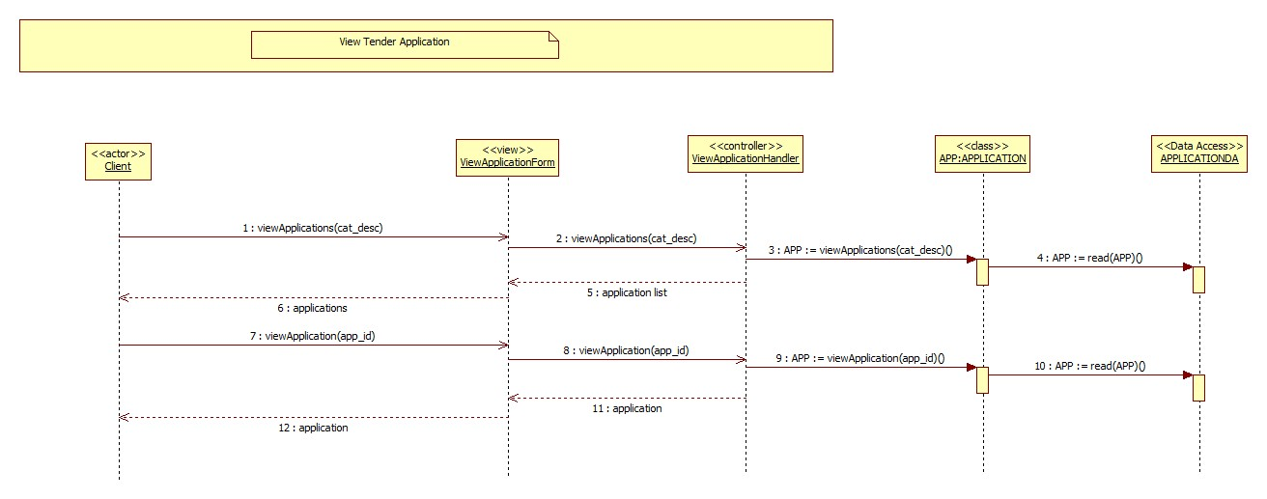

1. **[Cancel Tender Application]**

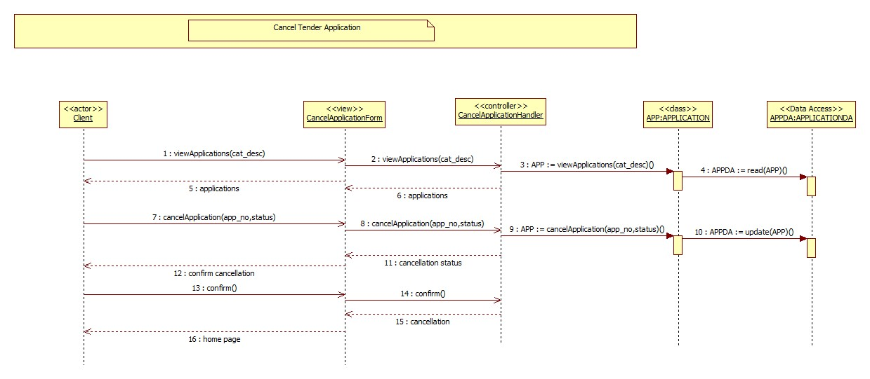

1. **[Update Tender]**

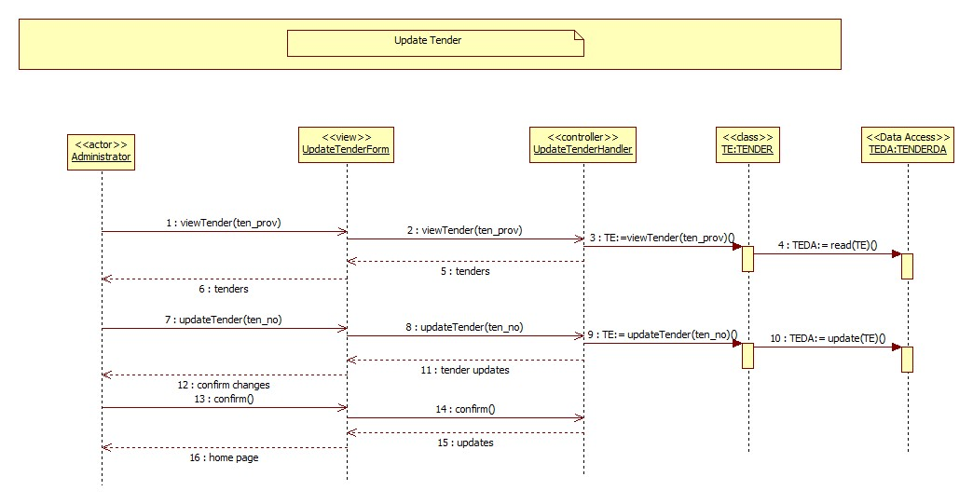

**B::UPDATED CLASS DIAGRAM**

1. **[Add Company]**

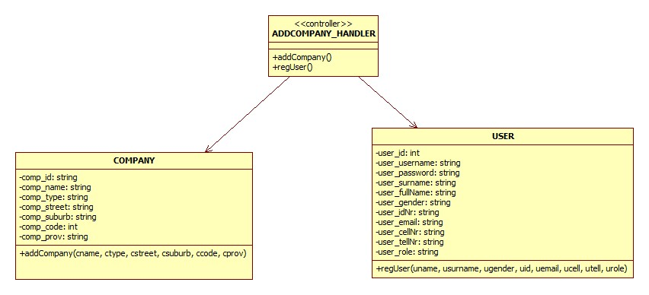

1. **[Advertise Tender]**

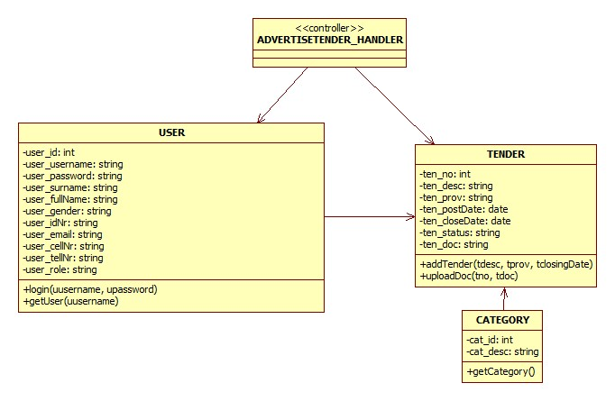

1. **[View Tender Application]**

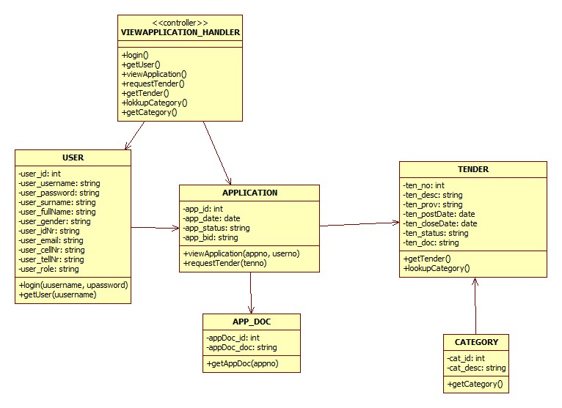

1. **[Cancel Tender Application]**

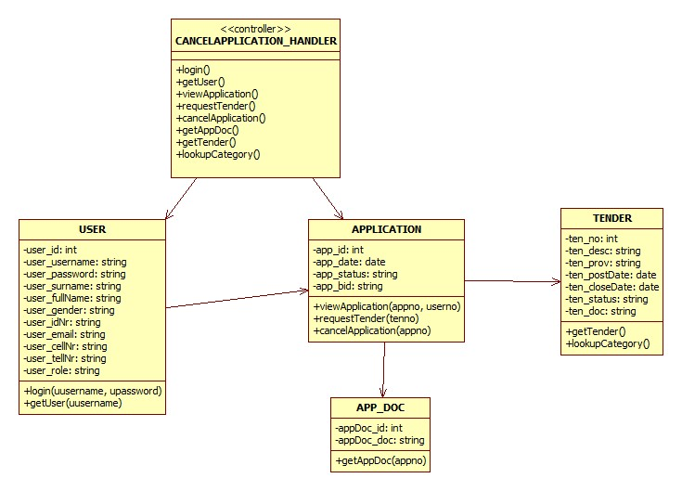

1. **[Update Tender]**

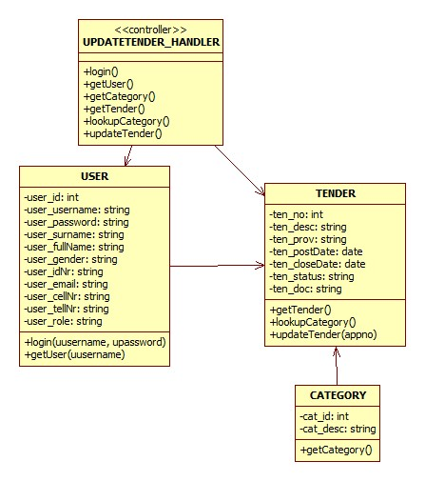

**C :: PACKAGE DIAGRAM**

1. **[Add Company]**

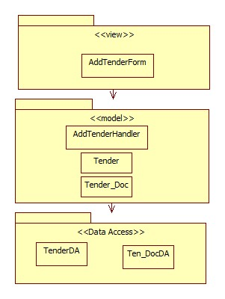

1. **[Advertise Tender]**

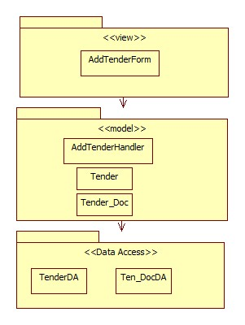

1. **[View Tender Application]**

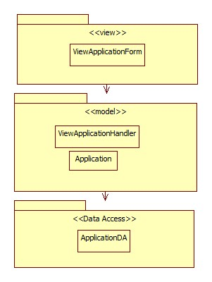

1. **[Cancel Tender Application]**

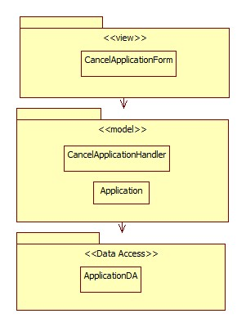

1. **[Update Tender]**

